**EGB240 Electronic Design**

**Assessment 1: PCB Siren Circuit Design Portfolio**

**Submitted 8/04/2022**

**Hari Markonda Patnaikuni (n10789511)**

**Executive Summary**

The following portfolio comprises of the design progression of a two-tone PCB Siren Circuit which includes the theoretical, experimental, and simulation processes used to achieve the final PCB design. The design was created to meet following specifications:

* Power by two AA batteries (3V supply)
* Siren to be turned on and off using a slide switch
* First oscillating frequency of 0.296 Hz to alternate between two tones
* First tone frequency of 4.44 kHz
* Second tone frequency of 2.051 kHz
* Total supply current of 0.02A
* The dimensions of the PCB are 54 x 28 (without the battery holder)

The design is built on a double layer PCB.

The design uses two polyester greencap capacitors and one polarised electrolytic capacitor. Also, the design utilises a Piezoelectric buzzer to output the two tones, two 1N4148 diodes, resistors, and a Hex inverting Schmitt trigger.

Contents

1. Circuit schematic 2

2. Summary of design and operation 3

3. PCB layout 5

4. Bill of materials 6

5. Assembly overlay 7

6. Photos of assembled prototype 8

7. Simulation circuit and results 9

Simulation model netlist (LTspice) 10

Simulation model SW plot (LTspice) 11

Simulation model TONE1 plot (LTspice) 12

Simulation model TONE2 plot (LTspice) 13

Simulation model TONE1 and TONE2 plot (LTspice) 14

Simulation model C2 charge and discharge plot (LTspice) 15

Simulation model C3 charge and discharge plot (LTspice) 16

8. Experimental results 17

References 21

# Circuit schematic

Figure 1 – PCB siren circuit schematic. Related to PCB layout shown in Figure 4.

# Summary of design and operation

To begin with, the design for this siren followed the information given in the datasheets of both the Piezoelectric buzzer and the Hex inverting Schmitt trigger.

The below equation was the key indicator for deciding on component values for the oscillators.

The k value shown in the above equations can be determined by referring to Fig 15 K-factor for 74HC14 which is found on page 12 of the 74HC14 Hex inverting Schmitt trigger datasheet. The referenced graph is shown below.

In addition to this, the target frequencies of both tones for the siren were determined to be at least 1 kHz and the high tone to be close to the 5 kHz peak in sound pressure as shown in the below Frequency and Sound Pressure Characteristics graph found in the PS1720P02 Piezoelectric buzzer datasheet.

Figure 2 - K-factor for 74HC14 (NXP, 2012) Figure 3 - Frequency and Sound Pressure Characteristics for PS1720P02 Buzzer (TDK, 2022)

As seen in the above graph for a circuit with a 3V VCC the K-factor is equal to 1.25. Hence, the K-factor used to calculate the frequency will be 1.25.

The siren design shown in section 1 of the report has three key segments which are required to achieve a two-tone siren. By utilising three relaxation oscillators this two-tone siren is attained. Three gates of a Schmitt trigger for the three oscillators. The model of the Schmitt trigger is a 74HC14 Hex inverting Schmitt trigger.

The first relaxation oscillator acts as a trigger oscillator due to its small inaudible frequency of 0.296 Hz. Two standard component values of and for the resistor and capacitor were used to calculate this oscillating frequency. The below calculations theoretically validate this.

The topmost relaxation oscillator produces a frequency of 4.44 kHz due to the resistor and capacitor values being 10 and 18nF respectively. Below are the calculations which verify this frequency value.

Whereas the bottom relaxation oscillator produces a frequency of 2.051 kHz due to the resistor and capacitor values being 10 and 39nF respectively. The below calculations verify this frequency value.

In addition to these components, two 1N4148 diodes were used to enable the altering between the two tones with the first diode being mirrored to the right when compared with the second diode. These diodes were placed just before each of the relaxations oscillators which are producing the audible tones. The buzzer used for this circuit is a PS1720P02 buzzer which is connected to both outputs of the audible oscillators. Finally, the switch used is an SS-12 which is used to turn the circuit on and off.

# PCB layout

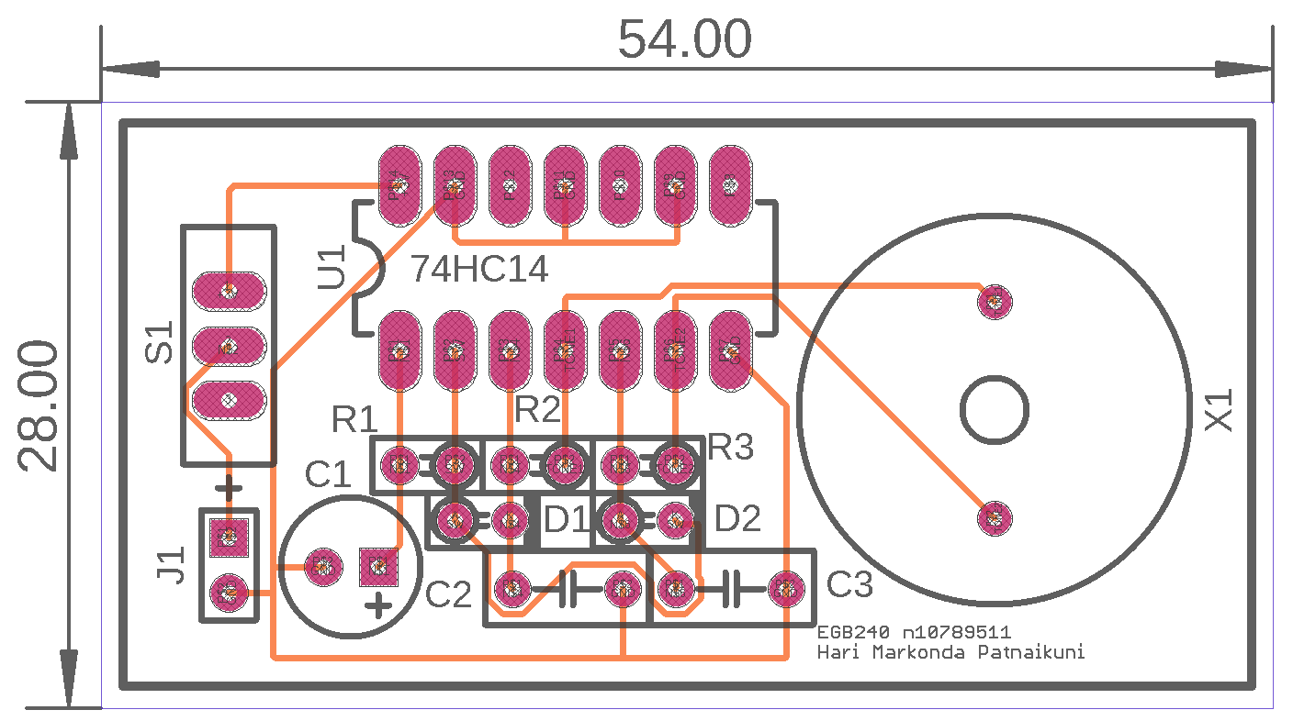Figure 4 - Siren circuit PCB layout with board dimensions in millimetres.

# Bill of materials



Table 1 – Bill of materials (BoM) for PCB siren design.

# Assembly overlay

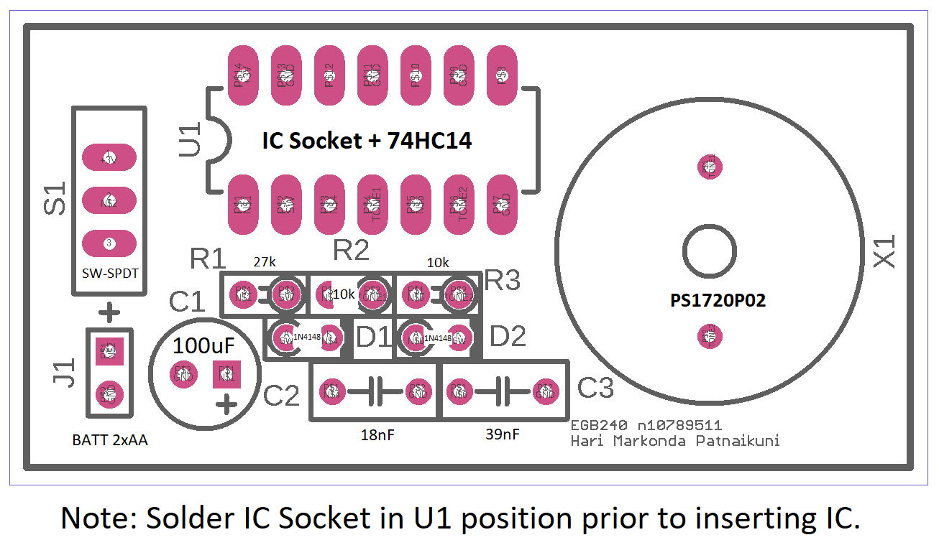

Figure 5 – Assembly overlay and instructions for siren circuit PCB design.

# Photos of assembled prototype

Figure 6 – Constructed prototype on breadboard showing power supply Figure 7 – Alternate view of prototype on breadboard. Scale in centimetres.

connections(Red – 3V, Blue 0V) and scale in centimetres.

# Simulation circuit and results

Figure 8 – LTspice Schematic with simulation command. Schematic details included in netlist of Figure – 9. All simulation results found in Figures 10 to 15 correspond to Simulation – Tone 1, Tone 2.

## Simulation model netlist (LTspice)

**\* Two Tone Siren Model**

**\* Simulation - Tone 1, Tone 2**

**.tran 0 10 1.1 startup uic**

**.wave Final2.wav 16 44.1k V(TONE1) V(TONE2)**

**.probe V(TONE1, TONE2)**

**.probe V(SW)**

**.probe V(C2)**

**.probe V(C3)**

**\* Gates are modelled to the specification of 74HC14 with 3V supply.**

**A2 C2 0 0 0 0 TONE1 0 0 SCHMITT Vhigh=3 Rhigh=34 Rlow=41 Cout=200p Vt=1.27 Vh=0.40 td=31n**

**R2 TONE1 C2 10k**

**C2 C2 0 18nF**

**XX1 TONE1 TONE2 PS1720P02**

**A1 N001 0 0 0 0 SW 0 0 SCHMITT Vhigh=3 Rhigh=34 Rlow=41 Cout=200p Vt=1.27 Vh=0.40 td=31n**

**R1 SW N001 27k**

**C1 N001 0 100µF**

**D1 SW C2 1N4148**

**A4 C3 0 0 0 0 TONE2 0 0 SCHMITT Vhigh=3 Rhigh=34 Rlow=41 Cout=200p Vt=1.27 Vh=0.40 td=31n**

**R3 TONE2 C3 10k**

**C3 C3 0 39nF**

**D2 C3 SW 1N4148**

**.lib C:\Users\hmark\Documents\LTspiceXVII\lib\cmp\standard.dio**

**.include PS1720P02.sub**

**.backanno**

**.end**

Figure 9 – Netlist for LTspice Schematic found in Figure 8.

## Simulation model SW plot (LTspice)

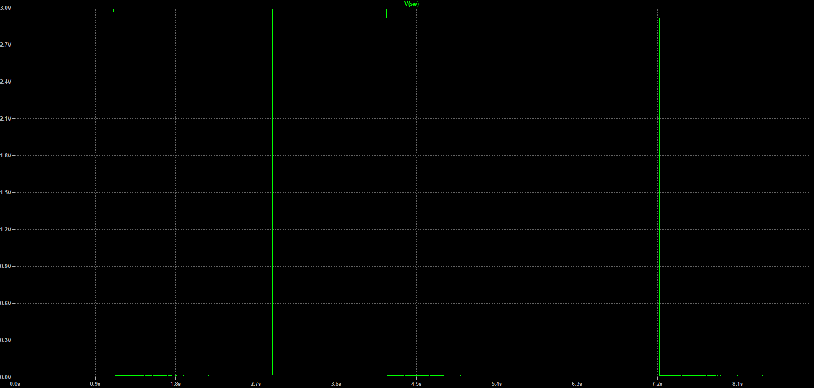

Figure 10 – LTspice plot of SW node shown in Figure 8. Shows frequency of oscillation at 0.296 Hz.

## Simulation model TONE1 plot (LTspice)

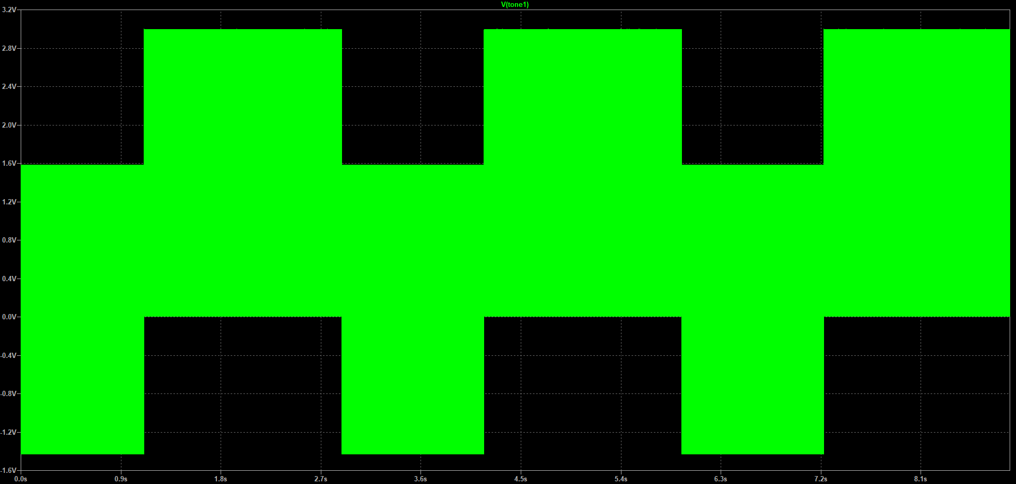

Figure 11 - LTspice plot of TONE1 node of buzzer shown in Figure 8. Shows frequency of TONE1 at 4.44 kHz.

## Simulation model TONE2 plot (LTspice)

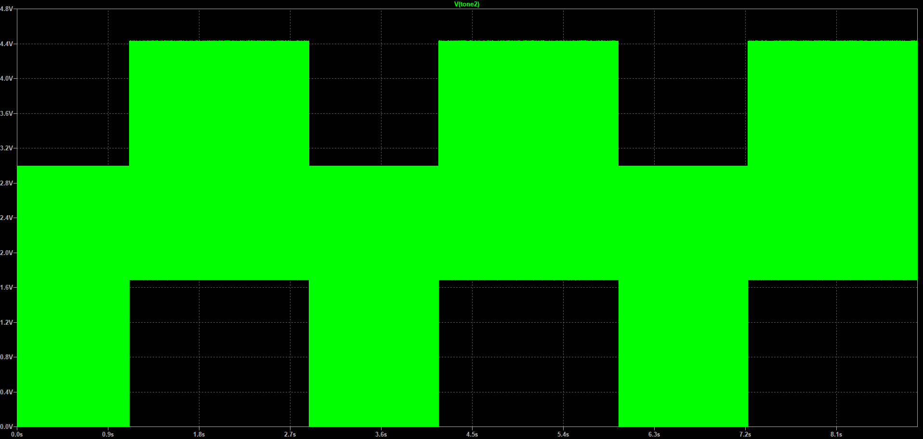

Figure 12 - LTspice plot of TONE2 node of buzzer shown in Figure 8. Shows frequency of TONE2 at 2.051 kHz.

## Simulation model TONE1 and TONE2 plot (LTspice)

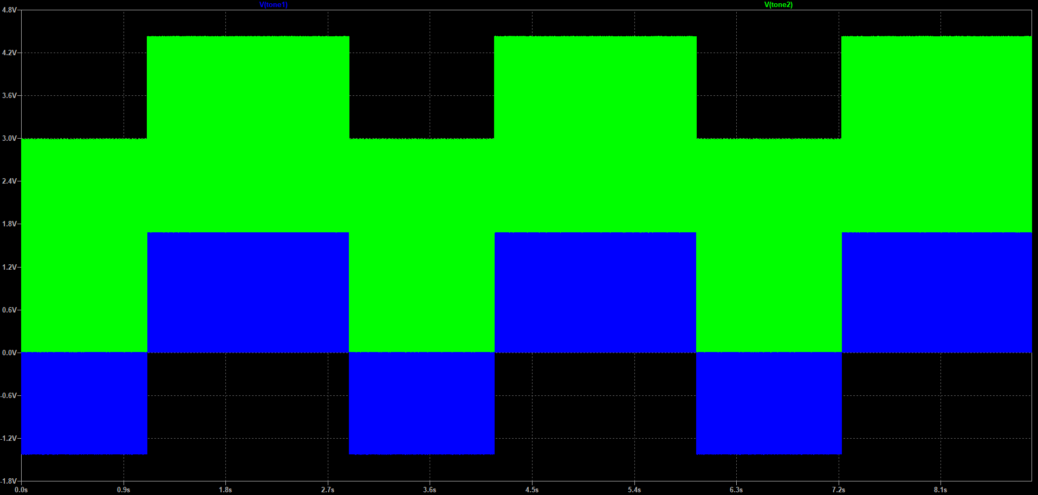

Figure 13 - LTspice plot of TONE 1 and 2 nodes of buzzer shown in Figure 8.

## Simulation model C2 charge and discharge plot (LTspice)

Figure 14 - LTspice plot of C2 node shown in Figure 8.

## Simulation model C3 charge and discharge plot (LTspice)

Figure 15 - LTspice plot of C3 node shown in Figure 8.

# Experimental results

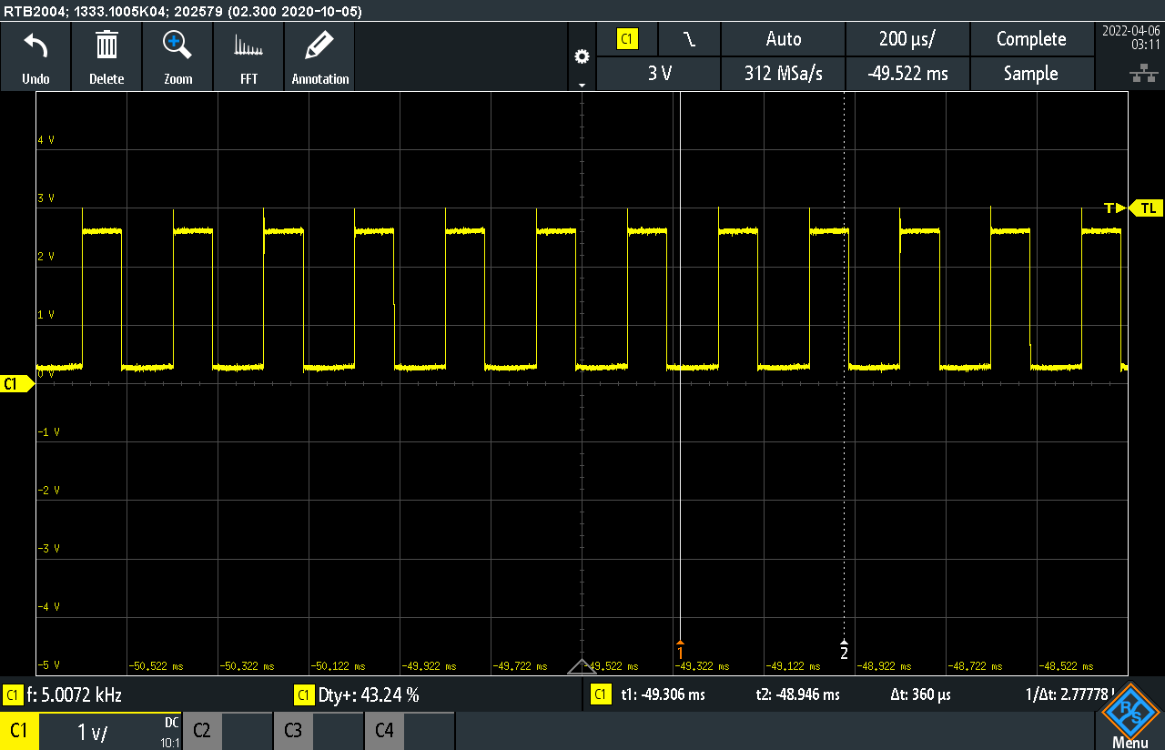

Figure 16 –TONE1(C1, yellow, 0.5V/div) waveform showing frequency of 5 kHz(≈ 11% higher than theoretical frequency(4.44 kHz)) and duty cycle of 43.2%

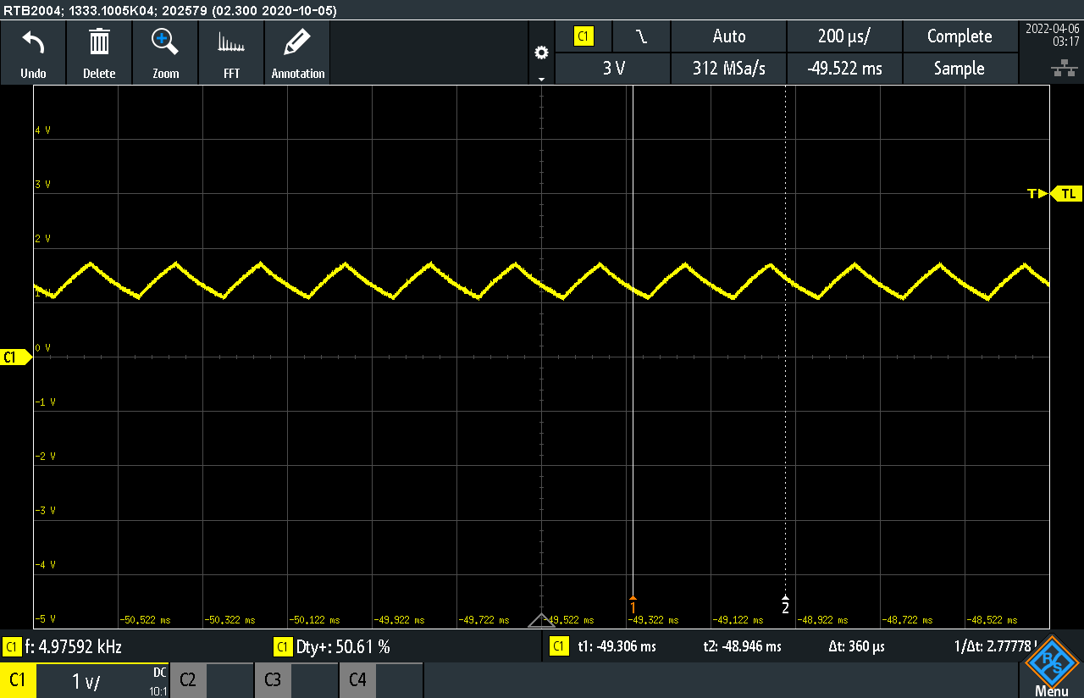

Figure 17 – C1(yellow, 0.5V/div) C2(18nF) charge and discharge waveform

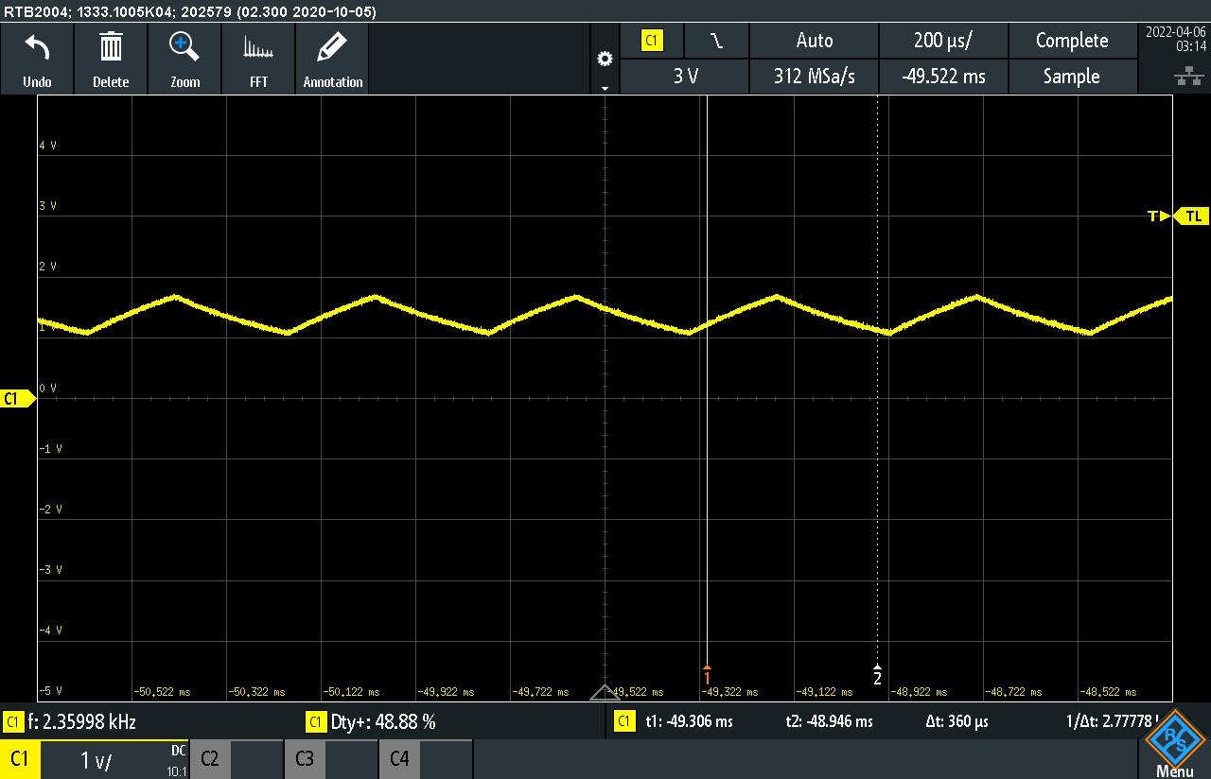

Figure 18 – C1(yellow, 0.5V/div) C3(39nF) charge and discharge waveform

Figure 19 – M1(turquoise, 0.5V/div) shows math function depicting tone alternating, C1(yellow, 0.5V/div) shows tone 2, C2(green, 0.5V/div) shows tone 1, C3(orange, 0.5V/div) shows trigger oscillator at 0.296 Hz switching between low and high.

# References

NXP. (2012, 9 19). *74HC14; 74HCT14 Hex inverting Schmitt trigger.* Retrieved 4 7, 2022, from Octopart: https://datasheet.octopart.com/74HC14N%2C652-NXP-Semiconductors-datasheet-141446461.pdf

TDK. (2022, 2). *piezoelectronic_buzzer_ps_en.pdf.* Retrieved 4 7, 2022, from TDK: https://product.tdk.com/system/files/dam/doc/product/sw_piezo/sw_piezo/piezo-buzzer/catalog/piezoelectronic_buzzer_ps_en.pdf